Green Guard: Smart certification platform
We have two portals
User portal
User creates account log in, start application process
The application process has steps
First it lists all the document required to get the certification
Give contacts of all the firms required to get the certification, if possible, the application integrates a messaging platform or maybe an email
The it lets them upload the files
Then there should be get feed back button which sends the file to AI model which is going to compare the files with the rules and give feedback on what to improve
Then at last there should be submit application which is activated after all the files are uploaded and sent to the authority

Admin portal
Login, check the progress
Compare the files with the rules and give score if fulfils the rule give certification send it back as pdf

I need about page , FAQ

1. Home Page
- Brief introduction to the platform.
- Call-to-action buttons ("Sign in ", "Learn More").
- Highlights of the benefits of using Green Guard.
2. About Page
- Explanation of what Green Guard does.
- Overview of the Estidama Pearl Building Rating System.
- How Green Guard simplifies certification.
3. FAQ Page
- Common questions about document requirements, AI feedback, and certification rules.
- Contact options for support.

Sign in leads to user portal or Employee portal
Which leads to Log in page

User Portal Pages
1, Log in page username and password create account option

2, User Dashboard (After Login)
• Displays application progress.
• Shows notifications and feedback from AI or admin
Allows download once certification is sent
3, application page
Required Documents
- Lists all documents needed for certification.
- Provides descriptions and examples.

Upload Documents
- Users can upload required documents for review.
- File preview and checklist for tracking uploaded files.
AI Feedback
- Users can submit documents for AI analysis.
- AI provides feedback on compliance and improvements.
Submit Application
- Users finalize and submit their application after completing all steps.
- Displays confirmation and tracking info.
4, Contact Firms Page
- List of approved firms & consultants who can provide required documents.
- Messaging or email integration (if included).
5, User Profile & Settings

Employee portal
1. Admin Dashboard
- View pending, approved, and rejected applications.
- Quick insights on the status of certifications.
2. Application Review Page
- Admins can review uploaded documents and compare them with certification rules.
- Provide feedback or request missing documents.
Scoring & Certification
- Assign scores based on rule compliance.
- Generate PDF certification for approved buildings.

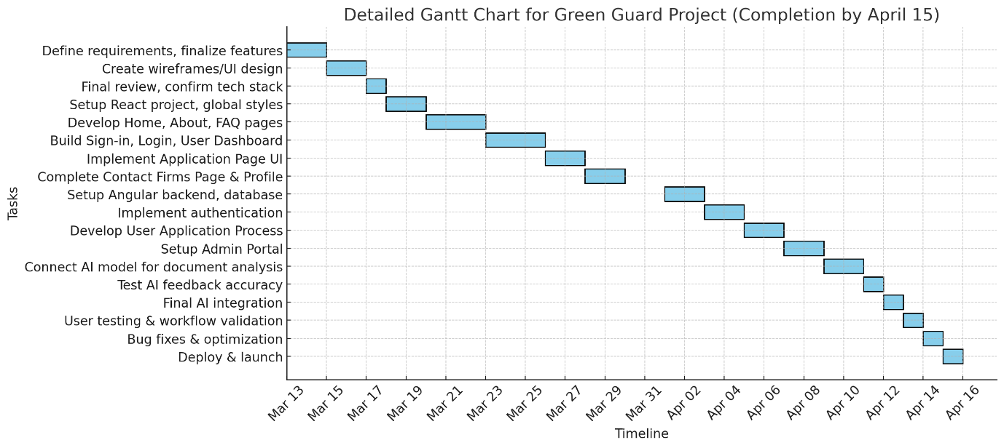

Detailed Phases & Timeline
Phase 1: Planning & Design (Mar 13 - Mar 17)
- Mar 13-14: Define requirements, finalize features
- Mar 15-16: Create wireframes/UI design for all pages
- Mar 17: Final review, confirm tech stack
Phase 2: Frontend Development (Mar 18 - Mar 29)
- Mar 18-19: Set up React project, create global styles
- Mar 20-22: Develop Home, About, FAQ pages
- Mar 23-25: Build Sign-in, Login, and User Dashboard
- Mar 26-27: Implement Application Page (Document upload, AI feedback UI)
- Mar 28-29: Complete Contact Firms Page & Profile Settings
Phase 3: Backend Development (Apr 1 - Apr 8)
- Apr 1-2: Set up Angular backend, database integration
- Apr 3-4: Implement authentication (Sign-in/Login)
- Apr 5-6: Develop User Application Process (Document storage, tracking)
- Apr 7-8: Set up Admin Portal (Dashboard, Application Review, Scoring)
Phase 4: AI Model Integration & Testing (Apr 9 - Apr 12)
- Apr 9-10: Connect AI model for document analysis
- Apr 11: Test AI feedback accuracy & optimize response time
- Apr 12: Final integration with frontend/backend
Phase 5: Final Testing & Deployment (Apr 13 - Apr 15)
- Apr 13: User testing (portal workflows, document upload, AI feedback)
- Apr 14: Bug fixes & performance optimization
- Apr 15: Deploy & launch Green Guard 🚀

